West Virginia University
College of Creative Arts
School of Theatre & Dance

HEDDA GABLER
by Henrik Ibsen
directed by Robynn Rodriguez

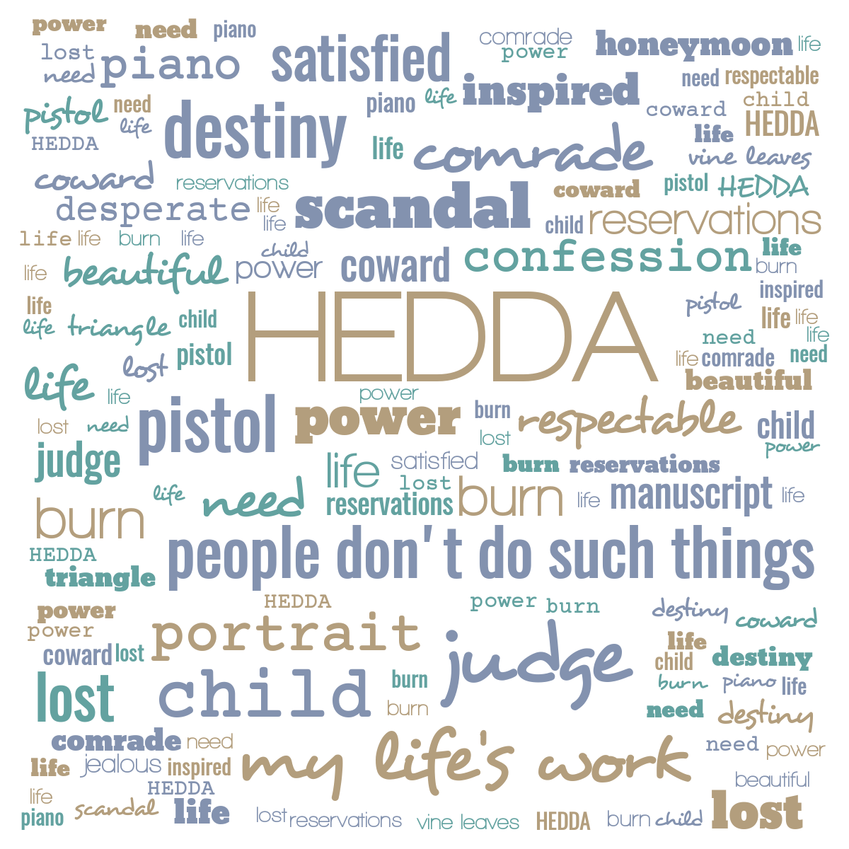
STUDY GUIDE
2020

Plot Summary
Hedda Tesman, née Gabler, returns from her honeymoon abroad to move into a new house with her husband, George. His longtime maid, Berte, joins the couple as their only servant, mostly through the generosity of his Aunt Juliana. The house was arranged for by a family friend, Judge Brack, and Hedda tries to furnish it to her liking, while George works on the research for his upcoming book. George’s rival for his anticipated professorship, Eilert Løvborg, has published a book of his own to positive reviews and has just completed a new manuscript that promises to shake up academic historians with its fresh take on all manner of topics. Løvborg has cleaned up his act recently with the help of Thea Elvsted, with whom he seems to be discreetly involved. Løvborg and Thea were at one time linked to Hedda and George, respectively, for a short time in the past.
Hedda learns of Thea and Løvborg’s relationship that seems an ideal partnership in the development of the new book and more, in great contrast to Hedda’s ennui and general dissatisfaction with her current life. She manipulates Løvborg into drinking once again, and in a night of carousing, Løvborg loses the manuscript which only George and Hedda know is safe in their house. Hedda’s antipathy to Thea and Løvborg’s relative bliss prompts her to destroy the manuscript, and we find out through the Judge that Løvborg has fatally shot himself (with one of Hedda’s prized pistols that she inherited from her father, General Gabler). Once Hedda realizes that her dreams of any kind of bearable life have disintegrated, she uses the other pistol to end her own misery.

HENRIK IBSEN

Open any book or website devoted to Norwegian playwright Henrik Ibsen (1828-1906) and it won’t be long before one confronts his epithet, “Father of Realism.” This is an unfair and constraining box in which to situate Ibsen’s breadth as an artist. While he embraced the new movement of dramatic realism begun by the French writers such as Émile Zola, Ibsen’s early works (and many of his later works) follow their own logic and reflect a poetic and artistic sensibility that becomes difficult to categorize cleanly.

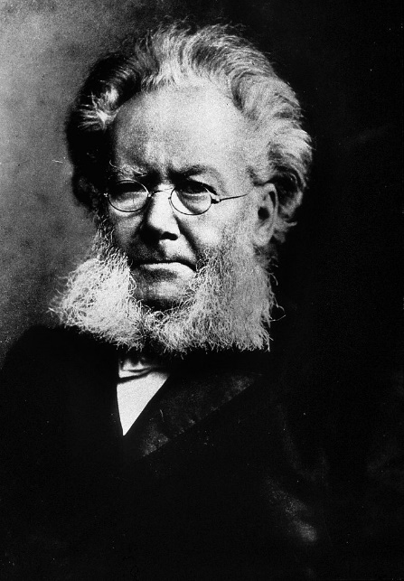
In his youth, Ibsen had a variety of small jobs, landing at the state theatre in Christiana (now Oslo). He worked his way up into a more important position, but his writing began to consume all of his time and thought. He left Norway at 26 and began to write more social and political plays, but ever Norwegian in their setting and consciousness. He returned to Norway in 1891, the year after Hedda Gabler premiered.

Ibsen’s best known and most important works include Peer Gynt (1867) A Doll's House (1879) Ghosts (1881) An Enemy of the People (1882) The Wild Duck (1884) and Hedda Gabler (1890). Photo of Henrik Ibsen, Wikipedia

The Well-Made Play

While at first the expression “well-made play” may seem complimentary, it is, in fact, a term of derision that describes a play that is a little too neat and tidy: all loose ends are tied up, there is an explanation for everything, and the plot often revolves around a simple misunderstanding over a prop like a letter or lipstick on a glass. In real life, and indeed in later “realistic” plays, playwrights emphasized the haphazard ways that life unfolds in a less predictable way, as the Nobel laureate British playwright Harold Pinter noted, “Our beginnings never know our ends.” Still, in the hands of many writers, the ends are often foreshadowed not by literary contrivance, but by the truth that human beings often repeat and continue on habits and behaviors that lead to crisis.

Ibsen’s dramaturgy has one foot in the well-made play style, but enhances it with an understanding of human nature and the latest advances in social science. Thus, the plot may be full of coincidences and a limited circle of society, but they are account-ed for in the circumstances that play out in the plot. Hedda Gabler contains a pair of former lovers (now romantically linked themselves), one of whom is also an old schoolmate of Hedda’s. Ibsen’s genius lies in taking this as a starting point, and not the solution at the end of the play.

He also makes use of the neo-classical unities of time, place, and genre (tone) in this particular play. The whole of the action takes place within twenty-four hours, creating a kind of pressure that forces decisions by several characters perhaps a bit too quickly and so unwisely. Hedda Gabler is trapped in the same house (and the audience in the same room) for the entirety of the play, another force on her psyche. Finally, there are few if any respites from the serious demeanor and subject matter discussed here; it is close to being a tragedy of bourgeois society.

Zola theorized that the proscenium arch (or the view from the audience in general) is a kind of picture frame containing the action, but for the purposes of Realism, it is a picture window, through which we may view the play’s happenings as one might watch the action on the street from our living room, or in reverse, peeking into someone else’s living room while passing on the street. Realistic plays are therefore glimpses into things simultaneously familiar and unique to their surroundings.
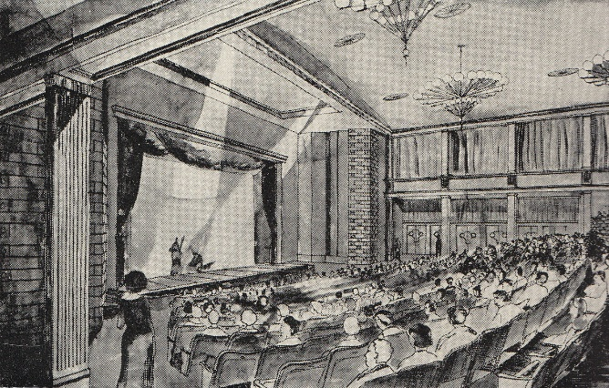
One of the very early outgrowths of Realism was Naturalism, a more deterministic view of the social pressures that foment the conflict and action on stage, making it clear that the growth of science in the nineteenth century added tools to interpret psychology, medicine, technology, economics, government, sociology, or any number of results from thinkers like Karl Marx, Charles Darwin, Louis Pasteur, John Stuart Mill, and later Sigmund Freud. Before Freud (and arguably before these other giants), playwrights like Shakespeare and Sophocles had to grapple with human behavior and psychology when writing their stories. With Ibsen, the wealth of ideas circulating in society lent credibility to Realism and Naturalism as an approach to art that mattered—reflecting and explaining the middle-class world we (think we) know so well.
https://www.theatre-architecture.eu/res/archive/233 /026407_52_292400.jpg

THEMES

Ibsen titles his plays, as all great playwrights do, to focus the audience’s attention where most beneficial to his purposes. And so, some are titled for the main character, as in Peer Gynt or Hedda Gabler; some for the thematic material, as in The Lady from the Sea or An Enemy of the People; and still others for symbols, as with The Wild Duck or A Doll’s House.

Building on our ideas of the so-called social “problem play,” the ideas presented in Hedda Gabler naturally come into question. In his earlier play The Wild Duck, Ibsen tackled the question of salvation through truth, having one character posit, “Rob a man of his life-illusion, and you rob him of his happiness in the same stroke.” There’s some of this same lesson in Hedda Gabler. This theme may be seen in the Hedda’s internal conflict over her conception of marriage and the ideal relationship she confronts between Løvborg and Thea. As the German playwright Johann Wolfgang von Goethe ( 1749-1832) quipped, “Love is the ideal, and Marriage the real; no confusion of the real and the ideal ever goes unpunished.” So it goes with Hedda in her current situation.

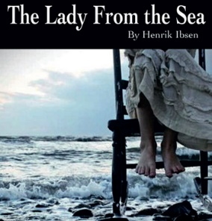
Most of the thematic material centers around the place and possibilities for women in society. Frustratingly, many of these same questions apply to our own society more than a century later. When asked whether he was a feminist author (Hedda, Nora in A Doll’s House, Ellida in The Lady from the Sea), Ibsen responded,

I must disclaim the honor of having consciously worked for the women’s rights movement. I am not even quite clear as to just what this women’s rights movement really is. To me it has seemed a problem of mankind in general. . . . True enough, it is desirable to solve the woman problem, along with all the others; but that has not been the whole purpose. My task has been the description of humanity.
—Speech at the Banquet of the Norwegian League for Women’s Rights, Christiana, May 26, 1898

Nevertheless, Ibsen’s abilities to draw out the very problems afflicting the women of his time makes him all the remarkable for his insights and depictions of his female characters and the men who surround them.

Interestingly and intentionally, Ibsen presents a variety of childless women on the stage. From the young serving girl, Berte, along with George’s maiden aunts (only Juliana appears in the play), with Thea’s marriage raising the children of her husband’s first wife, to Hedda who seems to bristle at even the hint of her being pregnant, the characters live on a spectrum of situations that militate against motherhood. Hedda feels this more deeply than the others, it seems, and uses the normative desires of women when she takes her revenge on Thea.

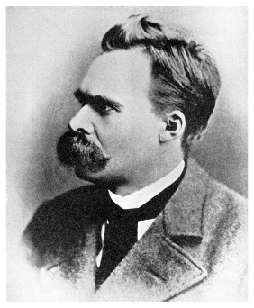
From the philosophical point of view of social scaffolding, Ibsen presents two conflicting views of creativity in the men: George is seen as a methodical, rational, organized, and thorough researcher, while Løvborg seems to produce his work in fits of inspiration and almost daemonic fervor. The German philosopher Friedrich Nietzsche (perhaps himself a bit of a model for Løvborg), wrote in The Birth of Tragedy (1872) of the dual creative modes in Greek drama: the Apollonian and Dionysian, whose qualities of form/dream versus frenzy/intoxication align perfectly with George and Løvborg, respectively.
F. Nietzsche / Getty Images

SOCIAL CLASS

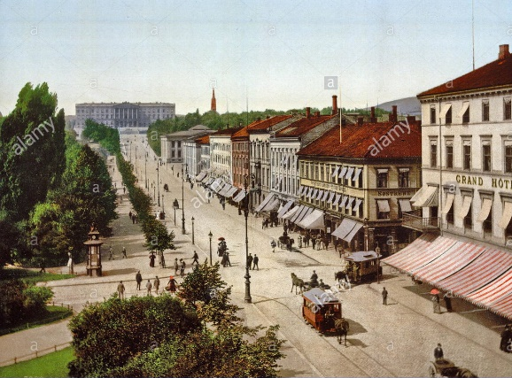
Hedda Gabler depicts the declining bourgeoisie of Europe that held social status and reputation paramount. As in August Strindberg’s heroine Miss Julie (premiered two years before Hedda Gabler), the landed gentry are marking time as they depreciate toward their last gasp of relevance in World War I. Miss Julie and Hedda share many characteristics of the generation that looked up to their fathers while anxious about their own potentialities in the quickly-changing society.

Christiana, Norway, the setting for the piece, may be seen to be a large enough city to be a capital, but rife with interlocking social circles and gossip.

Alamy stock photo

All of the characters in the play, with the exception of Judge Brack, seem to be at the risk of financial ruin or poverty: the aunt perhaps a little too generous with her pension, Løvborg trying to claw his way back into reputable society, Thea walking away from the security of her marriage, George unsure of his promotion, and Hedda clearly unhappy with the lack of advancement and security in her new marriage.

SYMBOLS

Ibsen’s approach to playwriting included the frequent and pointed use of symbols, while maintaining an appropriately realistic context (Peer Gynt’s Button Moulder and other hyper-symbols being a notable poetic exception to this). Thus, Hedda’s inheritance is not the usual dowry: from her father, the General, she received his portrait, his piano, and his pistols. These play together tellingly in the play and emphasize Hedda’s devotion to the man her husband would never live up to. The pistols are vital to the plot, but also stand in for Hedda’s masculine assertiveness in a rather obvious Freudian take on the import.

The most potent symbol, arguably, the manuscript, is built up to be the “child” of Løvborg and Thea. In the second half of the play, it is foremost in the mind of the characters and so the audience.

Other minor symbols add to the thematic material and represent character interests and the social class to which they belong.

CHARACTERS

Hedda Gabler Tesman—George Bernard Shaw, an ardent admirer of Ibsen’s, began his treatment of the play in his book The Quintessence of Ibsenism (revised 1913) by noting that

Hedda Gabler has no ethical ideals at all, only romantic ones. She is a typical nineteenth-century figure, falling into the abyss between the ideals which do not impose on her and the realities she has not yet discovered. The result is that though she has imagination, and an intense appetite for beauty, she has no conscience, no conviction: with plenty of cleverness, energy, and personal fascination she remains mean, envious, insolent, cruel in protest against others’ happiness, fiendish in her dislike of inartistic people and things, a bully in reaction from her own cowardice. (108-9)

Hedda has been brought up to be the General’s daughter. As such, she has enjoyed a certain lifestyle and living standard. In some respects, the play is her coming to terms with exactly how she has miscalculated this marriage to George and what it offers her in real ways.

“...Hedda is a woman, not a monster; neurotic, but not psychotic. Thus she may be held accountable for her behavior. But she is spiritually sterile. Her yearning for self-realization through exercise of her natural endowments is in conflict with her enslavement to a narrow standard of conduct.”(Mayerson 132)

While Hedda is indeed constricted by the society in which she lives, she has no real life ambitions to call her own. As Charles R. Lyons puts it in his book, Hedda Gabler: Gender, Role and World,

Hedda's only stable identity is as General Gabler's daughter. She has no life of her own, no projects of her own. Although she envies Eilert Løvborg's freedom and wildness, she shows no interest at all in the content of his writing, nor is she willing to risk scandal personally. She cooperates, in short, with the extremely limited role offered by her social condition (20)

The American director Harold Clurman underscores this “cowardice” on Hedda’s part, and sees it as a clear path to her own downfall.

Thea Elvsted—Not the most important secondary character, Thea matters most as a contrast to Hedda’s choices: Thea shows real bravery in walking away from her upstanding bourgeois home life to look after the man she truly loves, and with whom she has truly connected, Eilert Løvborg. Her life energy also stands in stark contrast to Hedda’s dismissive approach to most things (and people for that matter), and perhaps this is why George pulls her into his plan to do right by Løvborg in reconstituting the manuscript.

Eilert Løvborg—A rare individual, very Nietzschean in his understanding of the world and the forces that shape it. Still, flawed and a bit rudderless, he needs Thea more than he realizes. Not only is he Nietzschean, but Ibsen reinforces the Dionysian elements of this thinker by having Hedda continually look for “vine leaves” in his hair, a clear reference to the god of wine, theatre, and orgies. His fate is linked to Hedda’s more than he can apprehend.

George Tesman—A good man, to be sure, who feels he has “hit the jackpot” with the prospects for his book and marriage to one of the most prominent women in Christiana. Almost everything he does (apart from his research) is for others, he is caring, family-oriented, and at the mercy of his bride, who is none of these things. His true strength and morality come into play when he champions Eilert Løvborg and his ideas at the expense of his own publication demands.

Judge Brack—Ibsen draws the judge as a portrait of power. He is ruthless, manipulative, positioned in society, and has the means to make or break almost anyone in Christiana. He enters the conversation as the man who brokered the purchase of the house, and so starts off as a kind benefactor. As the play progresses, we understand more about him, although he does not change in any way, so that by the end we see him for what he has always been and what he will always represent.

Aunt Juliana Tesman—George’s aunt is the dearest person in the world to him. Not only does she oversee the happiness of George, but also of her own sister, George’s other aunt, Rina. She gives Hedda the benefit of the doubt until she can no longer avoid the truth that George’s young wife detests her.

Berte—Significant in that she was the Tesman maid when George lived with his aunts, Berte is caught in an uncomfortable situation, but does what she can to keep Hedda happy, and keep her job in the new household.

Director/Guest Artist, Robynn Rodriguez
Robynn Rodriguez made her professional directorial debut at the Utah Shakespeare Festival with an acclaimed production of Shakespeare's King John. Since that auspicious beginning, she has gone on to direct at USF, the University of Texas at Austin, Pacific Conservatory Theatre, Dartmouth College and American Players Theatre. Robynn has been teaching acting as well as directing school tours and community theatre since 1993. She is a sought after guest instructor and lecturer at theatre schools and colleges across the country. Website: robynnrodriguez.com

You've acted most of your life and moved to directing. How did you approach the new job description?
As I became an older and more experienced actor, I found that few young directors were coming to directing having had experience in other theatrical disciplines. To me it seemed as if they had a “process disconnect.” It’s as if some the directors I found myself working with had no real idea of what a designer, a stage manager, an artisan, let alone, an actor brings to the collaborative endeavor of working on a play. I found that in rehearsals, I had a desire to communicate the actor’s process effectively—to other actors. I couldn’t help other actors if I was acting with them. I slowly began to seek out an opportunity to direct to stave off my own frustration and disappointment with a less than stellar rehearsal process. What do you like best about the different role? I love the challenge of it . . . I am humbled by it . . . It is all encompassing. Every aspect of the production demands one’s time and attention. Now when I go back to work on a play as an actor, it is almost like a vacation.

Ibsen is a formidable figure in modern drama. What about his dramaturgy challenges you and excites you?
Ibsen is credited as being the father of theatrical realism. His writing is spare. The characters in his plays are complex. There are a lot of things going on at once in his plays, with his people. There is a lot going on between the lines. What people don’t say is as compelling as what they do say. In Ibsen plays, actors have a real oppor-tunity to take a deep emotional dive without the heavy trappings of production. There are no technical fireworks, no “bells and whistles,” no sweeping declamatory speeches. Just some very real, complex people trying very hard to live their lives. For the actor in an Ibsen play, the work is less about “acting” and more about “being."

What did you share with the cast on the first night of rehearsal about Ibsen from the adapter's intro?
“Ah Ibsen; yes.
In the panorama of contemporary writers, are any more dead, male, white and European than Henrik Ibsen? Yet modern literature, and particularly, dramatic literature, is impossible to imagine without him. He wrote in a language known to fewer than four million people in a syntax that was still in the process of formation, yet he became the most cosmopolitan and universal of writers. And the body of his work is both elusive and vital long after the controversies he challenged and inspired settled into the dust of history.”
— Jerry Turner
The Plays of Ibsen, Volume One: (From the Introduction)

How well did you know the play before you signed on to direct it here?
Only through my experience of theatre history and seeing several productions of the play. I was fortunate, as a young actor, to work on several Ibsen plays that were translated by Jerry Turner, the translator of our production at WVU. Jerry Turner was the Artistic Director of the Oregon Shakespeare Festival. He hired me to work in the company and directed me several times. I learned a lot about working on Ibsen from him.

What are some of the most salient elements you'd like this production to bring out? Perhaps with the exception of Shakespeare, no playwright before Ibsen could match his observations of women. In 2020, it is hard to imagine the seismic reactions to his plays and the women who inhabited them. Women who dare to become the agents of their own destinies—eschewing the constraints of their time and culture and most especially, the men in their lives. Ibsen's view of women and their challenges is very modern. I think today’s audiences will find that a lot of what Ibsen writes about is still resonant today.

You're not only working with student actors, but also student designers on this production. What special attention do you feel helps you to work in an educational theatre environment?
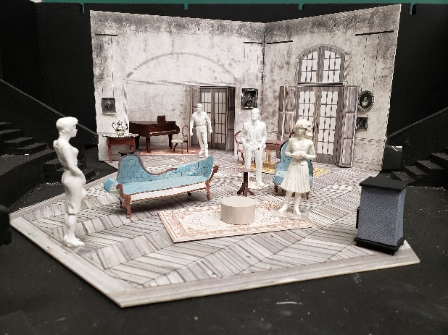
I hope that in our work together, the students will discover that the journey is as important as the destination. We all know how the play ends. Our work together must focus on how we make our way through the story of the play; of how we go about laying a foundation that breathes life into the words the playwright has given us. It is an exercise in patience. It is an exercise in trust. Collaboratively, all of us working on Hedda Gabler are charged with upholding Ibsen’s work. As Shakespeare’s Hamlet says, “the play’s the thing.” What special attention helps? I don’t know. I guess I hope that our experience together will leave the students inspired to go further, to dig deeper, to understand that in “play making” there is always something new to discover.
Model by Abigail Wagner for her scenic design at WVU

PRODUCTION HISTORY

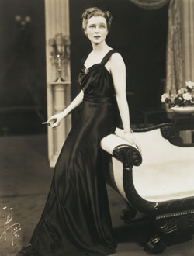
The role of Hedda is, in Western Drama, rivaled by another iconic female tragic heroine, Racine’s Phèdre, and quite possibly has been the equivalent of a Hamlet for its depth and demands on the actor. And so, the list of Heddas on stage reads like a Who’s Who of leading women of the last century with gravitas and poise: Vera Komissarzhevskaya, Eleonora Duse, Alla Nazimova, Asta Nielsen, Johanne Louise Schmidt, Mrs. Patrick Campbell, Eva Le Gallienne, Elizabeth Robins, Anne Meacham, Ingrid Bergman, Peggy Ashcroft, Fenella Fielding, Jill Bennett, Janet Suzman, Irene Worth, Diana Rigg, Isabelle Huppert, Claire Bloom, June Brown, Kate Burton, Geraldine James, Kate Mulgrew, Kelly McGillis, Fiona Shaw, Maggie Smith, Jane Fonda, Annette Bening, Amanda Donohoe, Judy Davis, Emmanuelle Seigner, Harriet Walter, Rosamund Pike, and Cate Blanchett. Major film productions have starred Ingrid Bergman, Diana Rigg, and Glenda Jackson.

Eva Le Gallienne as Hedda at the Civic Repertory Theatre, 1928

DISCUSSION QUESTIONS

Before you see the show:
- How important is upbringing in a person’s life? How much is someone influenced to want certain things, have certain expectations, or even come to a certain end?
- What does “Realism” promise for a theatrical experience?

After you see the show:
- How did the setting (scene design) add to your understanding of the action and the characters?
- How did costumes help to define character and circumstances?
- What character seemed most different from the beginning to the end? Why?
- Can you point to a place where the story could have turned on a completely different pivot, and ended more happily for all involved? Why do you think that didn’t happen?
- How would the play be different without the character of Judge Brack? Aunt Juliana?
- One of the thinkers of the time, George Brandes, observed that “Subjectivity is the Truth.” How might this apply to the characters and events depicted in Hedda Gabler?

BIBLIOGRAPHY

Auerbach, Erich. Mimesis: The Representation of Reality in Western Literature. Translated by Willard R. Trask. Princeton New Jersey: Princeton University Press, 1974.

Clurman, Harold. Ibsen. Masters of World Literature Series. Louis Kronenberger, General Editor. New York: Collier Books, 1977.

Krutch, Joseph Wood. "Modernism" in Modern Drama: A Definition and an Estimate. Ithaca, N. Y.: Cornell University Press, 1953. Rpt. by Cornell University Paperbacks, 1966.

Lowenthal, Leo. "Henrik Ibsen: Motifs in the Realistic Plays." In Rolf Fjelde, Ed. Ibsen: A Collection of Critical Essays. Englewood Cliffs, N.J.:Prentice-Hall, Inc., 1965, 139-157.

Lyons, Charles R. Hedda Gabler: Gender, Role and World. Twayne's Masterwork Studies, Robert Lecker, General Editor. Boston: Twayne Publishers, 1991.

Mack, Maynard, General Editor. The Norton Anthology of World Masterpieces. Fifth Continental Edition. New York: Norton, 1987.

Mayerson, Caroline W. "Thematic Symbols in Hedda Gabler." In Rolf Fjelde, Ed. Ibsen: A Collection of Critical Essays. Englewood Cliffs, N.J.:Prentice-Hall, Inc., 1965, 131-138.

Shaw, George Bernard. The Quintessence of Ibsenism. New York: Hill and Wang, 1913.

Sprinchorn, Evert (ed.). Ibsen: Letters and Speeches. New York: Hill and Wang, 1964.

Thomson, David. Europe Since Napoleon. New York: Alfred A. Knopf, 1960.

Compiled by Dr. Jay Malarcher, Production Dramaturg
jay.malarcher@mail.wvu.edu

