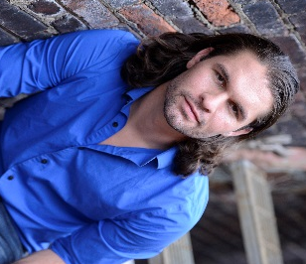
Joseph Michael-Kenneth
Height: 5’9”
Weight: 165
Eye& Hair: Brown
Bari-tenor (G2-A4)

josephmichael-kenneth.com
jgay08004@gmail.com
218.269.6782

Theatre:  Venus In Fur | Thomas Novachek | Vivian M. Davis
Assassins  The Beaux’ Stratagem  Pericles  Arms and the Man  On the Verge  Midsummer Night’s Dream HEADSHOT! (Devised Theatre) Pippin  Picnic Marat Sade  Wiley and the Hairy Man A Little Light  Little Women | John Wilkes Booth  Archer  Thaliard/Lysimichus  Bluntschli  The Man  Theseus  Ensemble Character  Player  Howard Bevans  Kokol  Narrator/Swamp Creature  1 Dancer/Pizza Man  Ensemble | Jay Malarcher  Metropolitan Theatre  Lee Blair  Gladys G. Davis  Richard Garner  Gladys G. Davis  Cornel Gabara  Weber Center  Trevor Walker  Weber Center  Richard Walters  Weber Center  Richard Walters  La Croix Black Box  Kari Margolis  Viterbo Mainstage  Matt Campbell  La Croix Black Box  Richard Waters  La Croix Black Box  Dana McConnell  Intl. Children’s Theatre Fest  Japan 2013  La Croix Black Box  Original Work  Viterbo Mainstage  Shane Rhoades
Film/Commercial  Tantamount (Jury Award)  Journalism 101 | Campus Movie Fest  Focus Group Ad Test | Festival de Cannes  Brabender Cox
Education & Training:
West Virginia University - MFA Acting (Anticipated Graduation, 2018)
Acting: Jerry Mcgonigle, Cathy O’Dell, Richard Garner, Cornell Gabara
Voice (Speech): Laura Hitt;
Movement: Jessica Morgan-Bishop
Voice (Singing): RJ Nestor
Viterbo University - BFA Theatre: Acting, BFA Arts Administration, Dance Minor, 2015

Workshops - Commedia, War Horse (New London Theatre), Stage Combat, Margolis Method

Special Skills/Workshops:
Dialects: RP, Irish, Scottish, New York; Basic Piano; Basic guitar; Trumpet; Good with animals (especially horses); Basic Fencing; Gollum voice; Hand whistle; Partner Lifts; Alexander Technique; licensed driver; valid passport; Techinical Theatre (see separate resume).

